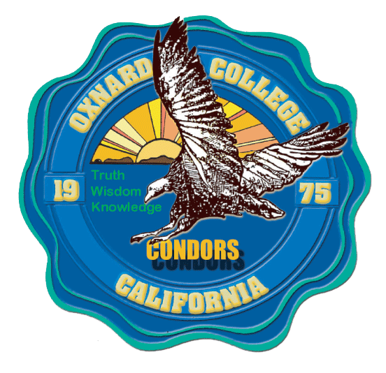
Oxnard College
Career and Technical Education Division

Computer Networking/IT - Industry Advisory Council Meeting
Friday, May 17, 2019

Agenda and Minutes

Industry Advisory Council Members Present:
Indy Batra, CEO, MJP Technologies
Michael Colmenares, IT Support, Santa Paula Unified School District
Michael Orechoff, DBA Manager, Reiter Affiliated
Rizwan Ahmed, Sr. Web Programmer, NDTI
Mike Colmenares, IT Technician, Santa Paula School District
Vince Carrasco, Network Admin, SA-TECH
Albert Wolfkiel, Network Admin, US Navy Base Port Hueneme. CNIT Adjunct
Marybeth Jacobsen, President and CEO, Workforce Education Coalition
Ed Garcia, CNSE Instructor, Moorpark College
Wayne Snyder, IT Instructor, VCCCD

- Welcome and Introductions
Meeting called to order at 10AM at the Pharos Center, Camarillo, California

- Course/Program Updates to Advisory Committee

Alex Lynch shared that the new CNIT R146 CompTIA PenTest+ course that was recommended by the advisory council the prior year, was scheduled to be offered in fall 2019 and a hiring committee was being formed to hire a new instructor to teach this course. Alex encouraged advisory board members to help get the word out about the new course and encourage their IT employees to take this new course which is a newer CompTIA cybersecurity certification.

Alex announced that the new Python programming course was set to be offered in the spring semester and Kevin Rickard was slated to be the instructor. Alex reminded the group that this course would be offered via the Cisco Networking Academy.

It was also shared with the group that the CNIT R131 Windows Server course was now using Server 2019 per the recommendation of the advisory council at the previous meeting last spring.

- New Cybersecurity CoA

Alex Lynch solicited feedback on the sequence of courses to be considered for the new Cybersecurity CoA that is scheduled to be proposed to the Curriculum Committee the following academic year.

CNIT R120 - Cisco CCNA I or CNIT R144 - Network + Cert Prep. – 4 units
CNIT R145 - CompTIA Security + - 3 units
CNIT R146 – CompTIA PenTest+ - 3 units
CNIT R143 - CompTIA Linux + - 3 units
CNIT R127 – Wireless Networking – 3 units or (one or the other) CNIT R146 – Microsoft Windows Server – 3 units

There was general acceptance from the group regarding the sequence of courses that were proposed to make up the new CoA. There was some debate about whether CNIT R127 or CNIT R146 should be included. Rizwan stated that getting some scripting in the Microsoft Windows course would be valuable and Indy stated that a lot of networking is wireless and this is only increasing so students should be versed on the 802.11 standards and wireless security standards. In a show of hands, more advisory board members recommended the CNIT R127 course over the CNIT R131 course. It was shared that scripting may be included in one of the other courses that are part of the CoA.

Vince Carrasco applauded that a CoA in Cybersecurity was moving forward because of the need and high paying jobs available in cybersecurity. The group was pleased to hear that the CNIT Program was responding to industry need in the area of cybersecurity.

- Internships

Alex thanked the members present that sponsored IT interns during the academic year.
There was a reminder that the COT R190V Internship is 1-unit for 60 hours and can be taken up to 4 times. It can even be taken multiple times in a semester.

Alex Lynch reminded the group that it is very important to make sure that the interns only perform IT work and not other types of manual labor and to make sure that IT work is not a long duration repetitive task that does not foster new IT knowledge or hands on skills.

Alex shared with the group the success stories where CNIT interns were being hired into f/t IT jobs including Florence Toralba at MJP Technologies, Brittney Yates at SwiftChip, and Joe Demmatia at OUHSD.

Indy Batra shared that they are in a growth mode and they are looking to continue sponsoring many IT interns in the upcoming year and if they prove themselves, they have a demand for new IT technicians.

- Additional Feedback from Industry

Several members of the advisory council shared once again the importance of soft skills training in the CNIT program and courses. Indy shared that it is 50/50, as far as half of their success depends on their IT skills and half their success depends on their soft skills. Rizwan shared that there are some special considerations when working with a defense contractor including security clearance. Vince shared that he likes to take the time with interns to walk them through an entire solution and also stresses documentation. Mike Colmenares shared that there can be a lot of wasted time if documentation is not done properly due to technicians doing repetitive work and it can also cause a technician to have to start from scratch if they do not see the previous solution to the same problem. He also shared that working in a school setting, it is important to always keep a level head and not talk down to faculty who may be very novice as it relates to IT.

In general, advisory committee members applauded the CNIT program for being proactive in including soft skills activities into the courses including writing in lab reports, research and presentation projects, and discussion questions that encourage critical thinking and peer review. It was noted that team labs provide the opportunity to develop interpersonal skills when tackling a IT tasks and when performing troubleshooting.

Meeting adjourned at noon.

